
ALLDERDICE PTO

PTO/PSCC MEETING AGENDA

April 15, 2021 @ 6 pm
Join Microsoft Teams Meeting

· Welcome – Mike Bridges
· Minutes Approval - Approval of March Meetings Minutes
· Communications Update -Danielle Nicol and Darcy Gordon
· Treasurer Report – Jo-Jo Monaco
Dragon Spirit Wear Disposition
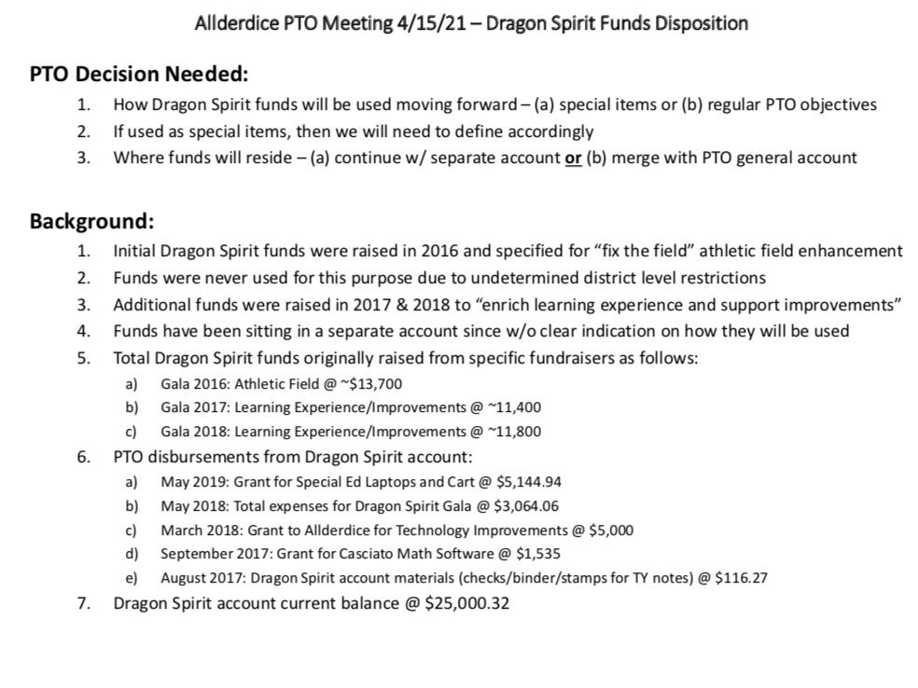

· Spiritwear -Leslie Grodin
· Grants Report – Laurie Heller Tarr, Lisa Naveh, Sarah Sirlin
- Three grants to review
- Nearpod.com Gold Plan mdiaz1@pghschools.org Amount requested: $120
- Mobile Apps and Gaming cmilius1@pghschools.org
$806.13
- WPC Garden Sponsorship nschmiedlin1@pghschools.org- Amount requested: $1300

· Teacher Appreciation Day- Open Discussion
· Principal Report - Dr. McCoy
· FACE Report – Raechel Palmer and Jess Porter
· Questions and Open Discussion

PSCC TOPIC: Celebrating Dice Students’ Accomplishment
NEXT MEETING: Thursday, May 20 th, 2021 @ 6pm...“Drugs and Alcohol” with Debbie Stewart

Join our PTO mailing list for announcements about meetings and volunteering opportunities at special events. Membership is free and open to any adult involved with students at Allderdice.
Enroll at our website https://allderdicepto.org
Contact us at any time prezallderdicepto@gmail.com

